**Practical-8**

**Aim:-** Develop an application for text editor using file handling concepts. Application should be able to create, edit the existing and save the text documents.

Code:Form1.cs

using System;

using System.Collections.Generic;

using System.ComponentModel;

using System.Data;

using System.Drawing;

using System.Linq;

using System.Text;

using System.Threading.Tasks;

using System.Windows.Forms;

using System.IO;

namespace Practical_8

{

public partial class Form1 : Form

{

public Form1()

{

InitializeComponent();

}

private void newToolStripMenuItem_Click(object sender, EventArgs e)

{

richTextBox1.Text = " ";

}

private void saveToolStripMenuItem_Click(object sender, EventArgs e)

{

SaveFileDialog saveFileDialog1 = new SaveFileDialog();

saveFileDialog1.Filter = "Text File|*.txt|PDF file | *.pdf | Word File | *.doc";

DialogResult dr = saveFileDialog1.ShowDialog();

if (dr == DialogResult.OK)

{

File.WriteAllText(saveFileDialog1.FileName, richTextBox1.Text);

}

}

private void openToolStripMenuItem_Click(object sender, EventArgs e)

{

OpenFileDialog openFileDialog1 = new OpenFileDialog();

if (openFileDialog1.ShowDialog() == DialogResult.OK)

{

richTextBox1.Text = File.ReadAllText(openFileDialog1.FileName);

}

}

private void printToolStripMenuItem_Click(object sender, EventArgs e)

{

PrintDialog printDialog1 = new PrintDialog();

if (printDialog1.ShowDialog() == DialogResult.OK)

{

MessageBox.Show("Print Successfully!");

}

}

private void exitToolStripMenuItem_Click(object sender, EventArgs e)

{

Close();

}

private void copyToolStripMenuItem_Click(object sender, EventArgs e)

{

richTextBox1.Copy();

}

private void pasteToolStripMenuItem_Click(object sender, EventArgs e)

{

richTextBox1.Paste();

}

private void undoToolStripMenuItem_Click(object sender, EventArgs e)

{

richTextBox1.Undo();

}

private void redoToolStripMenuItem_Click(object sender, EventArgs e)

{

richTextBox1.Redo();

}

private void cutToolStripMenuItem_Click(object sender, EventArgs e)

{

richTextBox1.Cut();

}

private void selectAllToolStripMenuItem_Click(object sender, EventArgs e)

{

richTextBox1.SelectAll();

}

private void colorToolStripMenuItem_Click(object sender, EventArgs e)

{

ColorDialog colorDialog1 = new ColorDialog();

if (colorDialog1.ShowDialog() == DialogResult.OK)

{

richTextBox1.ForeColor = colorDialog1.Color;

}

}

private void fontStyleToolStripMenuItem_Click(object sender, EventArgs e)

{

FontDialog fontDialog1 = new FontDialog();

if (fontDialog1.ShowDialog() == DialogResult.OK)

{

richTextBox1.Font = fontDialog1.Font;

}

}

}

}

**Form1.cs[design]**

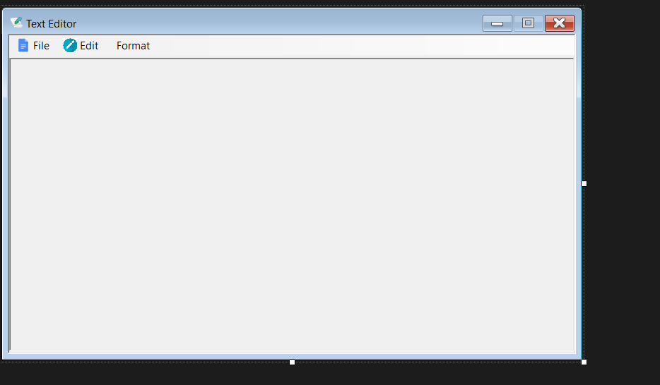

Output:

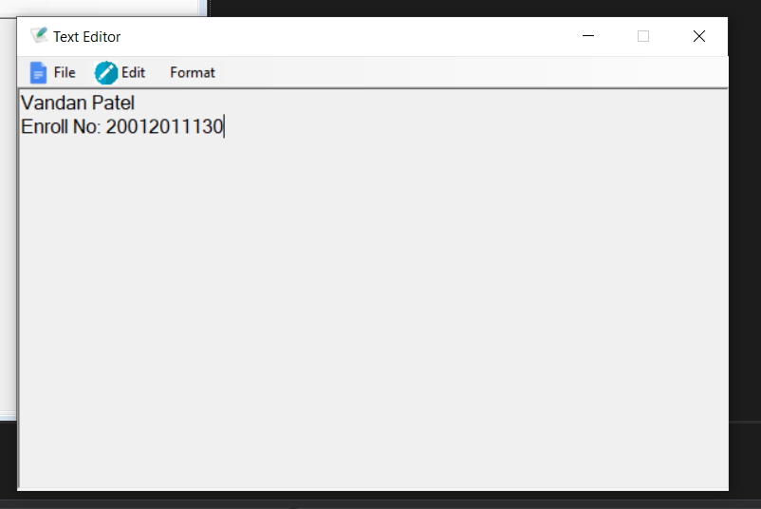

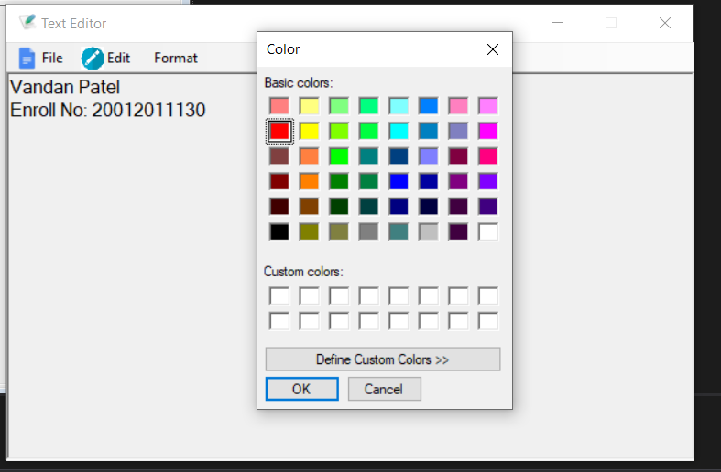

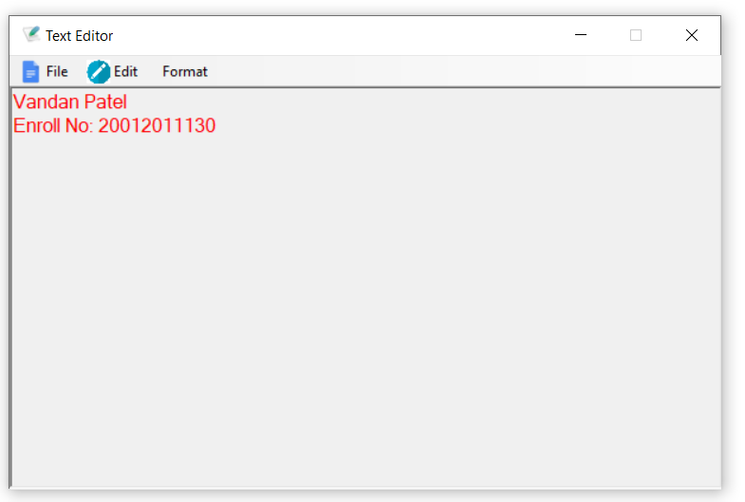

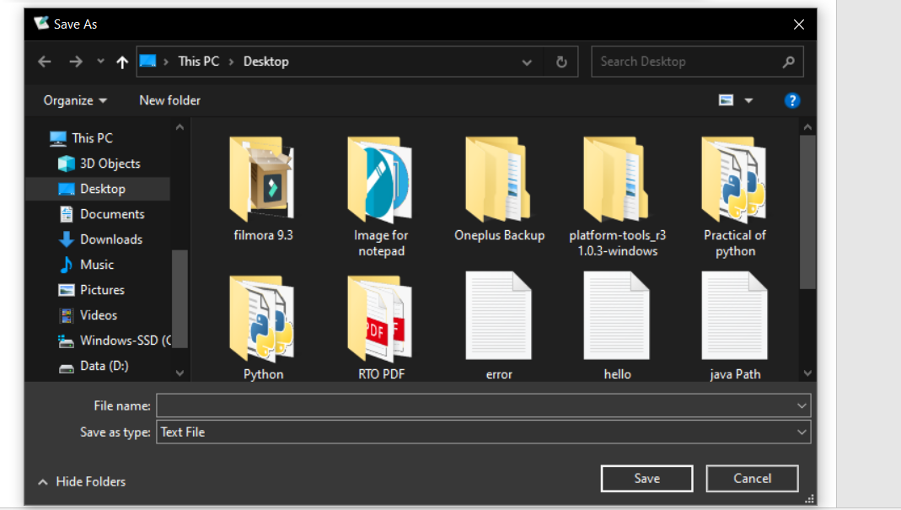

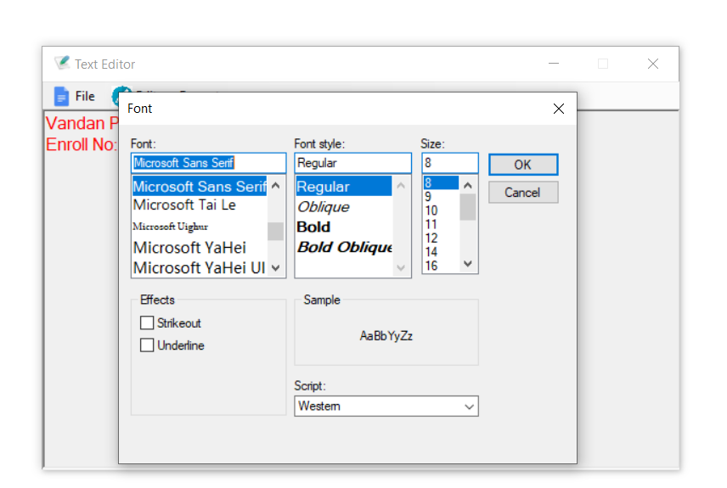

New File

